BANKING SYSTEM REQUIREMENTS ELICITATION MOCK INTERVIEW

Client: Themba Moeng

Interviewer: Student- Lebone Sebeso

Date: 17/09/25

**Interviewer (Student)**: Should customers receive notifications (SMS/email) after every deposit, withdrawal, or transfer? And should it also send messages when there is suspicious activity like overspending or using the card multiple times per day

**Client (Lecturer):** Yes you are able to add notifications to show transfers and deposits of those accounts but there is no need to add suspicious activity notifications.

---------------------------------------------------------------------------------------------------------------------------------

**Interviewer (Student):** Should the system allow joint accounts (more than one customer linked to the same account)?

**Client (Lecturer)**: It is not a necessary feature. Just focus on individual account usages and not joint accounts unless you are able to do so.

-----------------------------------------------------------------------------------------------------------------------------------

**Interviewer (Student):** Do you want the system to support standing orders or scheduled payments (e.g., automatic monthly transfers)?

**Client (Lecturer):** monthly interest should be calculated automatically by the system.

-----------------------------------------------------------------------------------------------------------------------------------

**Interviewer (Student):** Should the system allow customers to reset their own password, or must it be done by bank staff?

**Client (Lecturer):** Yes customers should be able to reset their own passwords

----------------------------------------------------------------------------------------------------------------------------------

**Interviewer (Student):** Should there be restrictions for underage customers (e.g., accounts requiring a guardian)?

**Client (Lecturer):** There are no age restrictions for when opening accounts

---------------------------------------------------------------------------------------------------------------------------------

**Interviewer: (Student):** How will a new customer register their account?

**Client (Lecturer):** The customer has to fill out a registration form with personal details and verify their identity using either an omang or passport

Banking system requirements

**Functional requirements**

**Customer Management**

* **Register customers with firstName, address, email, phone**
* **Update customer personal details**
* **Retrieve customer accounts by account number**

**Account Creation**

* **Create SavingsAccount (initialDeposit: 500.00)**
* **Create InvestmentAccount (initialDeposit: 500.00)**
* **Create ChequeAccount (employerName, employerAddress)**
* **Link accounts to customers and branches**

**Deposit Operations**

* **Process deposits with amount and date**
* **Update account balance positively**
* **Record deposit transactions**

**Withdrawal Operations**

* **Process withdrawals with balance validation**
* **ChequeAccount: validate employer details before withdrawal**
* **Record withdrawal transactions**

**Interest Application**

* **Apply 0.05% interest to SavingsAccount and InvestmentAccount**
* **Update balance with calculated interest**
* **Log interest as special transaction**

**Balance & Reporting**

* **Retrieve current account balance**
* **Generate transaction details report**

**Branch Integration**

* **Associate accounts with branch code and address**
* **Retrieve branch information**

**Non-Functional Requirements**

**Performance**

* **Transactions complete in < 2 seconds**
* **Handle 500+ concurrent transactions**

**Security**

* **Encrypt sensitive customer data**
* **Require authentication for all actions**
* **Maintain audit trail for transactions**

**Reliability**

* **99.9% system uptime**
* **Transaction rollback on failures**
* **Daily backups with < 1 hour recovery**

**Usability**

* **Clear validation error messages**
* **User-friendly interfaces/APIs**

**Scalability & Maintainability**

* **Support 10,000+ accounts**
* **Comprehensive unit tests**
* **Follow SOLID principles**
* **Easy extension for new account types**

CLASS DIAGRAM

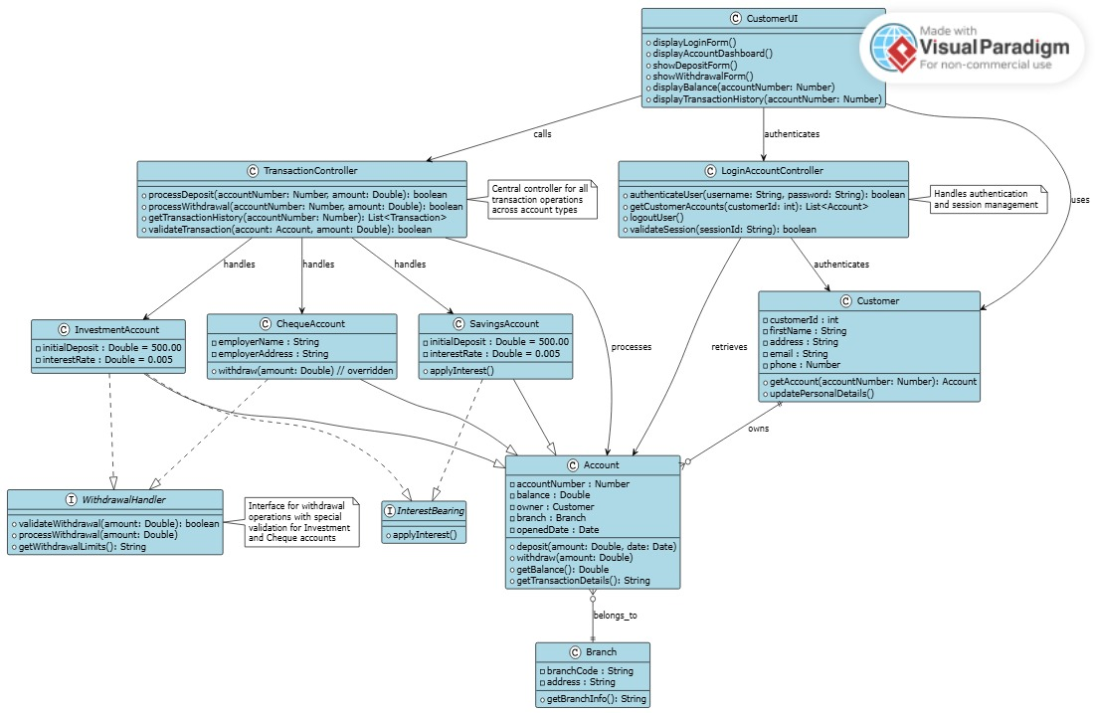

STATE DIAGRAM

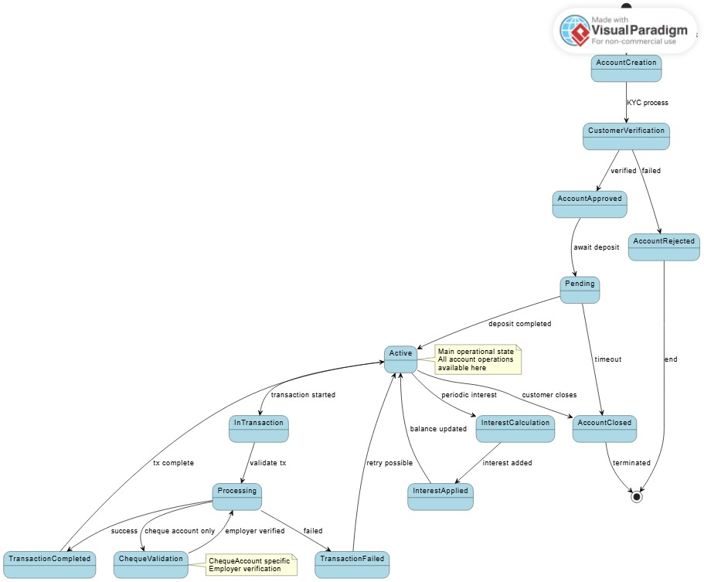

SEQUENCE DIAGRAM

